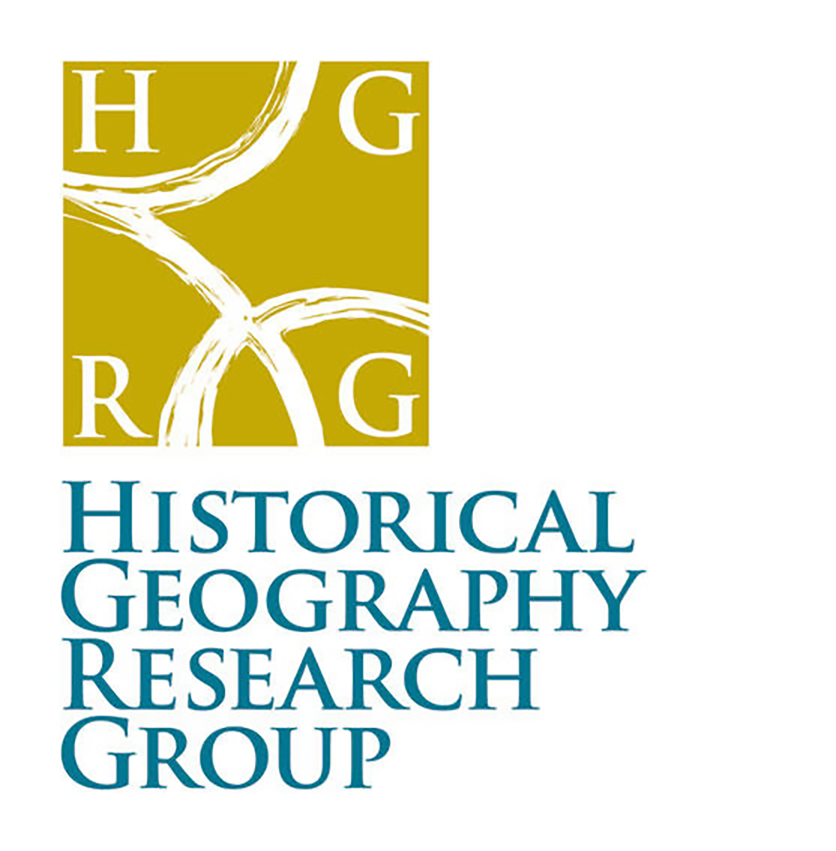

Decolonising Historical Geographies.

Practising Historical Geographies (#PHG2020)
Conference 2020
ONLINE via Zoom

Tuesday 24th November 2020 – 12:00 noon – 3pm GMT
and
Tuesday 8th December 2020 – 12:00 noon – 3pm GMT

Registration for delegates by 23rd November 2020: https://www.eventbrite.co.uk/e/practising-historical-geography-2020-tickets-126216800849

Note: all times listed in the programme are set at GMT / London time in order for maximum global virtual attendance.

Programme timetable for 24th November (session 1) and 8th December (session 2)

A Practising Historical Geographies 2020 workshop workbook (PDF created by Geography Workshop Productions on behalf of HGRG)
will be available to all delegates to support discussions in both workshop sessions. In addition to workshop reading / resources, suggested and further readings / resources connected with the work of Keynote speakers will be included to support delegates in their historical research after this event. Additional blank pages will be included should delegates wish to print the document out and write in it.

This workbook will be referred to across both sessions that together make up the virtual PHG 2020. Please ensure you have access to it for these sessions.

Tuesday 24th November 2020 Session 1
12:00 | Welcome and Introduction (10 mins)  Decolonising Historical Geographies  An introduction to the theme | Dr Cheryl McGeachan, Chair, HGRG  (University of Glasgow)  Dr Joanne Norcup, Conference Officer HGRG (University of Warwick / Nottingham)
12:20 | Keynote Finding place and family heritage in the archive: genealogical geographies for the people of Punjabi descent.  (45 mins + 10 mins Q&A) | Chandan Mahal (QMUL)
13:15 | Rest / tea break (5 mins)
13:20 | Workshop 1: Introduction (10 mins) | Conference theme overview and aims for this conference. Dr Joanne Norcup
13:30 – 14:20 | Workshop 1  Small group reading and reflections and feeding back to delegates (including a 5–10 minute rest / tea break) | Group work. Delegates will be allocated to a breakout group chaired by a member of the HGRG in which to reflect on a selection of excerpts  .
14:30 | Postgraduate Reflections | Dr Catherine Oliver (University of Cambridge)
14:50 | Conclusions and action points for session 2 (10 mins) | Dr Joanne Norcup  Suggested reading (Workshop booklet)

Tuesday 8th December 2020 Session 2
12:00 | Welcome, recap, and aim for the session | Dr Cheryl McGeachen, Dr Jo Norcup, Dr Hannah Awcock
12:15 | Keynote 2 ‘Only one recipe for decolonising historical cultures? Personal insights from the heritage sector’( 45 minutes + 10 min Q&A) | Keynote: Clifford Pereira FRGS (Heritage Consultant and Researcher)
13:10 | Rest / Tea break
13:15 | Workshop 2  Decolonising historical praxis – practical action points.  Reflecting on delegates own work and research plans, discussion around one of the three readings from last session that has facilitated broader questions about the process of undertaking research | Reflecting on readings from Workshop 1, scaffold questions to think about how you might decolonise your specific area of research interest.  Consider: *Literature used / citation practise; *Methodologies (approaches / framework / archives), *Analytical approaches, outputs (whose ideas are you applying? What are the effects and consequences of such ideas in terms of voices heard / erased? How, what and where do you see your work being of use, How will you sustain and maintain connections and work with the archives you use and for whose benefit?)  Time to work individually and across your group to discuss approaches and note down questions for further consideration to help inform / reflect on your own practise.
14:15 | Screening of Decolonise The Archive (DTA) film Whilst you archive me (Nadeem Din-Gabisi, Etienne Joseph, Connie Bell)  https://www.decolonisingthearchive.com/archive-me  Also read Etienne Joseph and Connie Bell (2020) Everything is everything: Embodiment, affect, and the Black Atlantic archive. Themed intervention. TIBG http://doi.org/10.1111/tran.12380  For further details about DTA and their projects see https://www.decolonisingthearchive.com
14:30 | Final reflections and end of PHG 2020  Ongoing conversations are encouraged and welcomed.  HGRG Virtual Writing Retreat 2021  January 5th – 7th (Tuesday, Wednesday, Thursday) 2021 we will be having our annual virtual HGRG ‘Writing Retreat’. All historical geographers across all stages of writing research and careers are welcome to join in as much or as little as personally needed / able. This is an opportunity to connect between with historical geographers and be in virtual company to work on whatever research / writing work you are undertaking. Previous years have proven popular and those taking part have found it enjoyable to start the new year by clearing some or all of the three days in which to attend to research. If you wish to take part you are free to do so and can share as much or as little via the hashtag #HGRG_VWR2021.  For further details please check HGRG website from the 15th December 2020.

